**An Analysis of Career Trajectories: Salary & Experience Across Global Industries**

**1. Project Objective:** The objective of this project is to conduct an in-depth analysis of salary trends across various global industries, examining how factors such as experience, education, job title, and location influence earnings. Through this study, I aim to identify salary patterns, disparities in compensation, and the impact of additional monetary benefits across different demographics. The insights gained will help professionals make informed career decisions and assist organizations in developing fair compensation structures.

**2. Dataset Description:** The dataset used in this analysis consists of multiple attributes, including:

* **Demographics:** Age Range, Gender
* **Employment Details:** Industry, Job Title, Clarification of Job Title
* **Earnings:** Annual Salary, Additional Monetary Compensation, Currency, Other Currency, Income Clarification
* **Location:** Country, State, City
* **Experience:** Years of Professional Experience Overall, Years of Professional Experience in Field
* **Education:** Highest Level of Education Completed

**3. Steps Involved:**

**Step 1: Data Cleaning and Preprocessing**

1. **Handling Missing Values:**
   * I identified missing values in multiple columns, particularly in salary and job title fields.
   * For numerical fields (e.g., Annual Salary), I used median imputation to maintain data integrity, while for categorical fields (e.g., Industry, Job Title), I replaced missing values with "Unknown" where appropriate.
2. **Standardizing Data Types:**
   * I ensured that all numerical data were stored in the correct format, and categorical variables were standardized to avoid inconsistencies.
3. **Handling Inconsistent Values:**
   * I noticed variations in job titles (e.g., "Software Engineer" vs. "S/W Engineer") and resolved them by mapping similar roles to a standardized format.
   * Location fields had inconsistent formats (e.g., "USA" vs. "United States"), which I normalized for consistency.
4. **Checking for Outliers:**
   * I detected extreme outliers in the salary column using statistical methods such as the IQR method and addressed them by capping extreme values or removing erroneous data points.
5. **Saved the Cleaned Dataset** for further processing in MySQL.

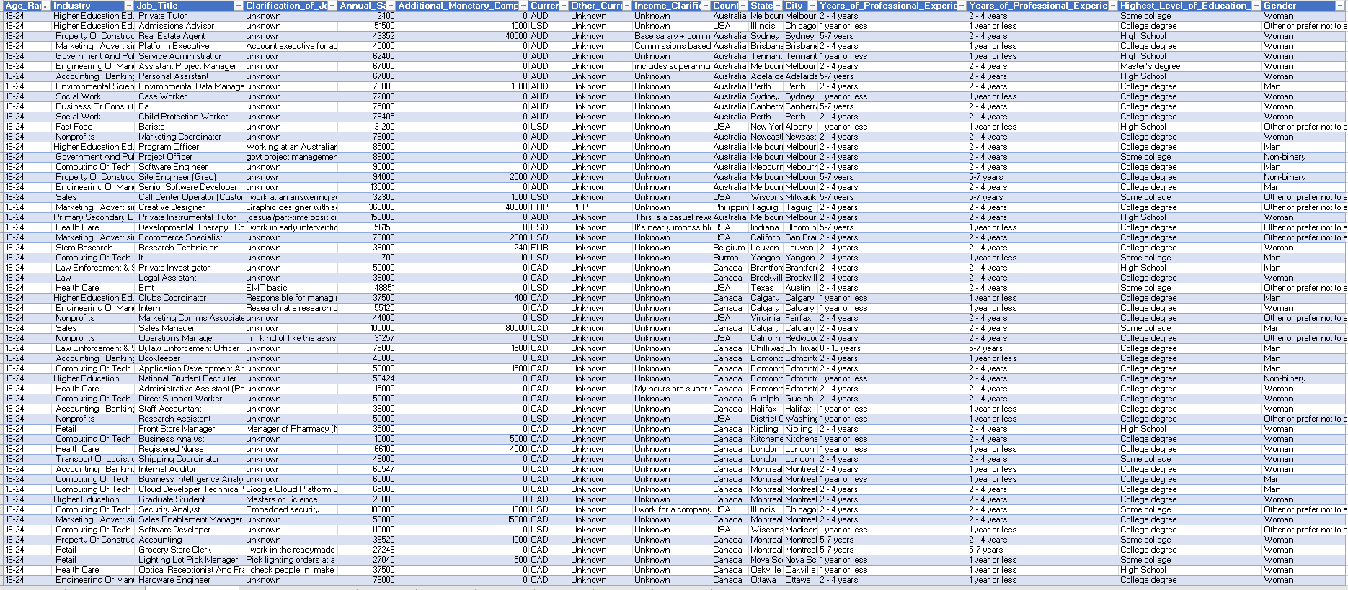

**Step 2: Storing Cleaned Data in MySQL**

1. **Created a Database in MySQL** to store the cleaned salary data.
2. **Defined a Table Schema** to ensure the correct data types for each attribute.
3. **Uploaded Data** using the MySQL Workbench import tool and validated the entries to ensure a successful data load.

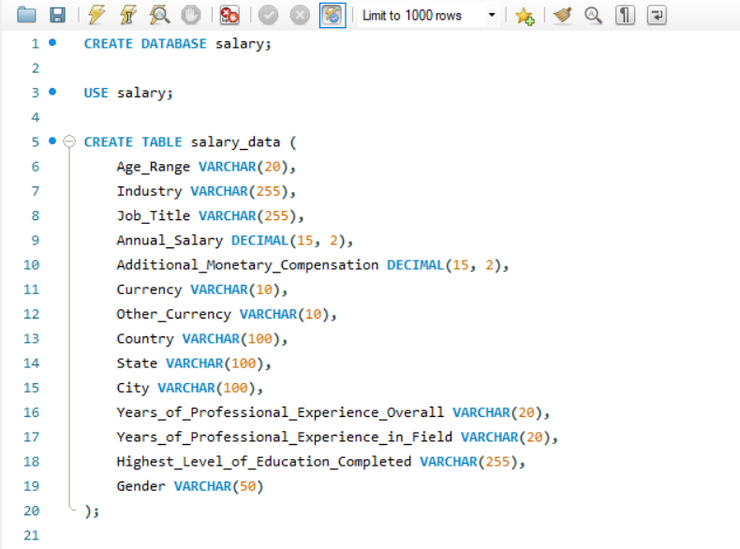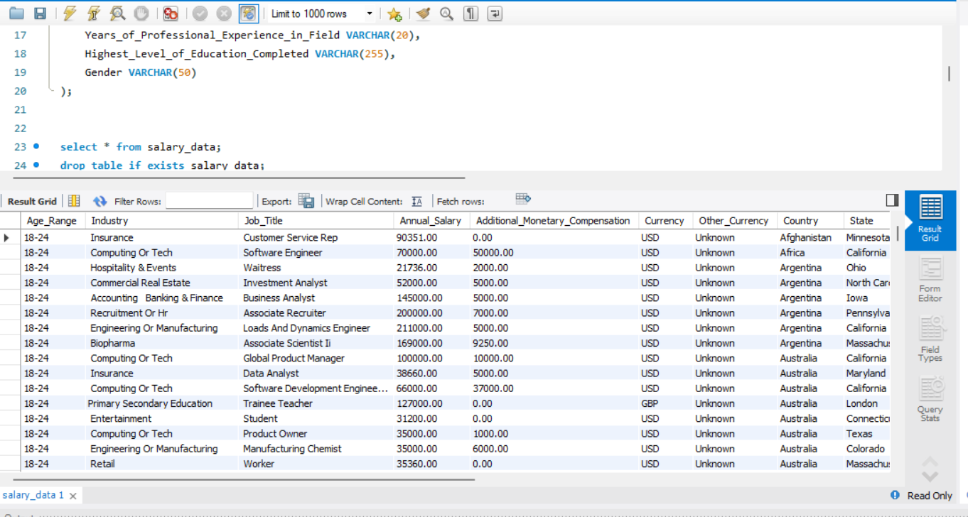

**Step 3: Query Data for Dashboard Creation**

I wrote and executed several SQL queries to extract meaningful insights:

1. Average Salary by Industry and Gender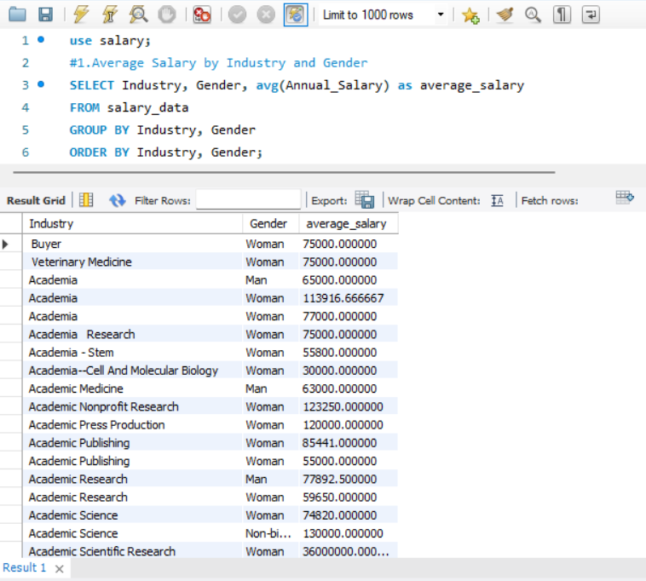
2. Total Salary Compensation by Job Title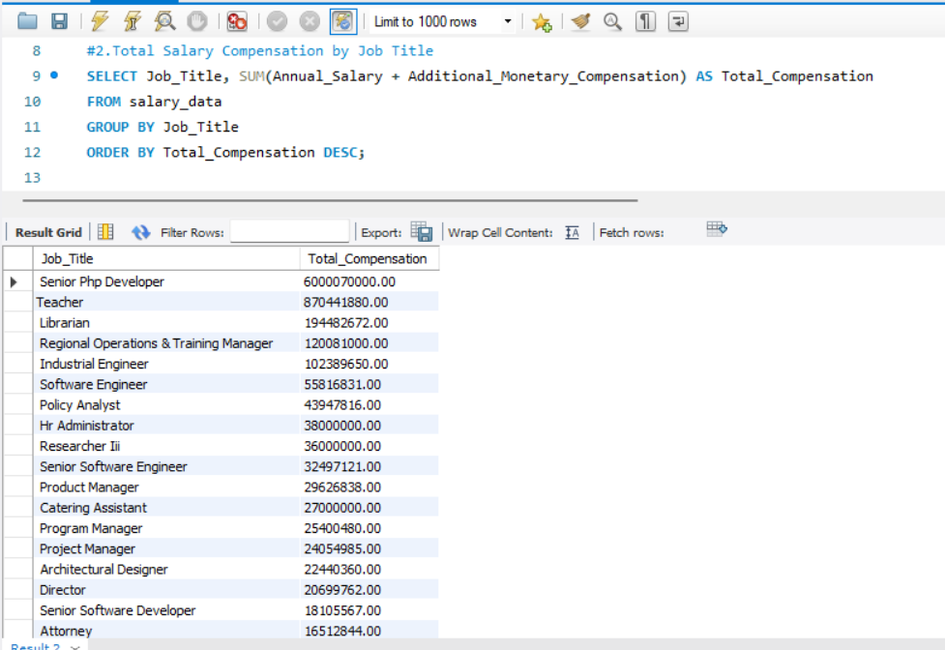
3. Salary Distribution by Education Level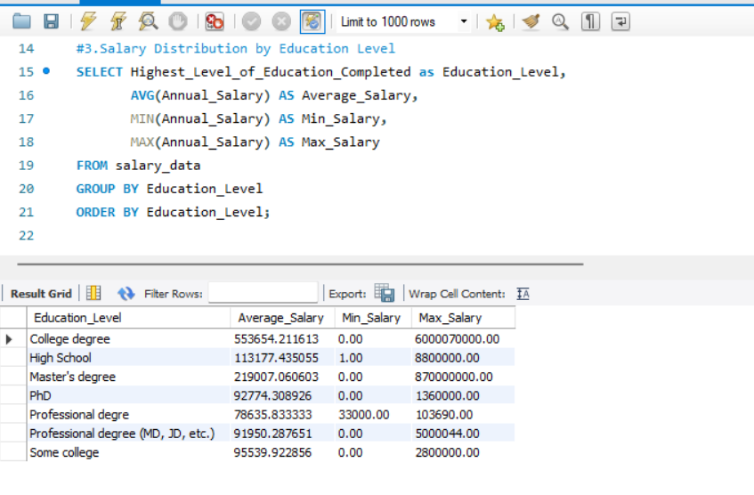
4. Number of Employees by Industry and Years of Experience

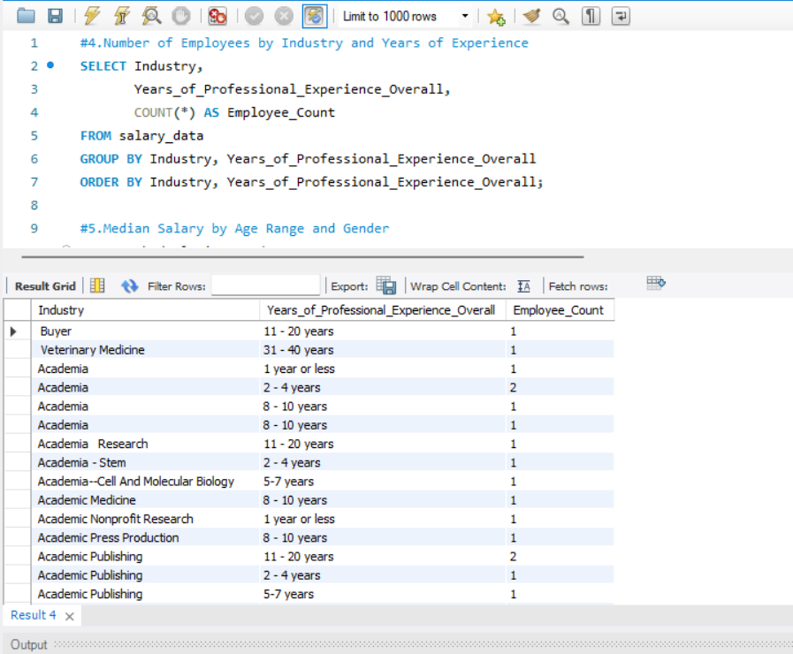

1. Median Salary by Age Range and Gender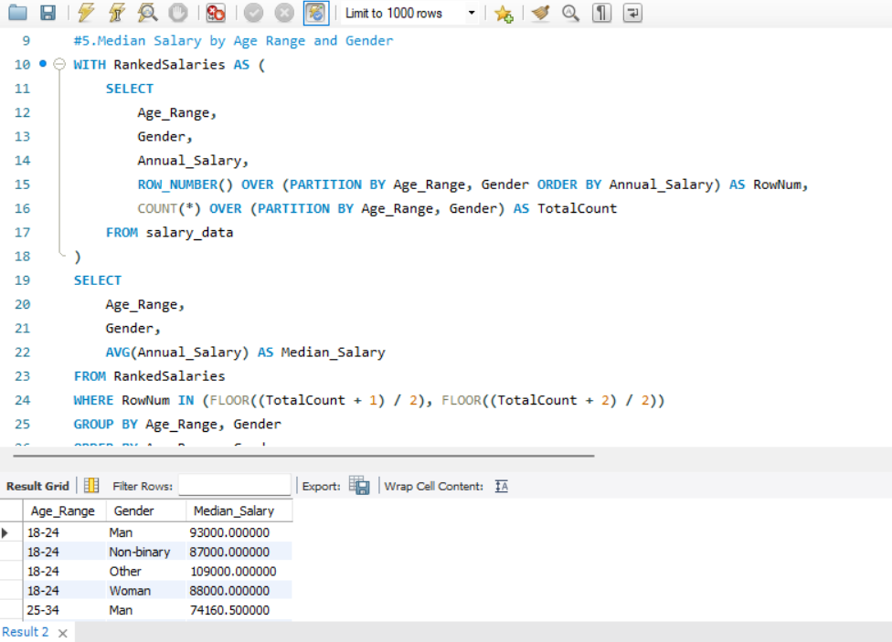
2. Job Titles with the Highest Salary in Each Country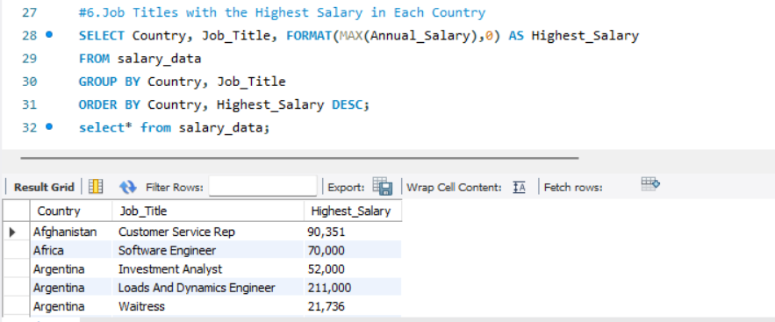
3. Average Salary by City and Industry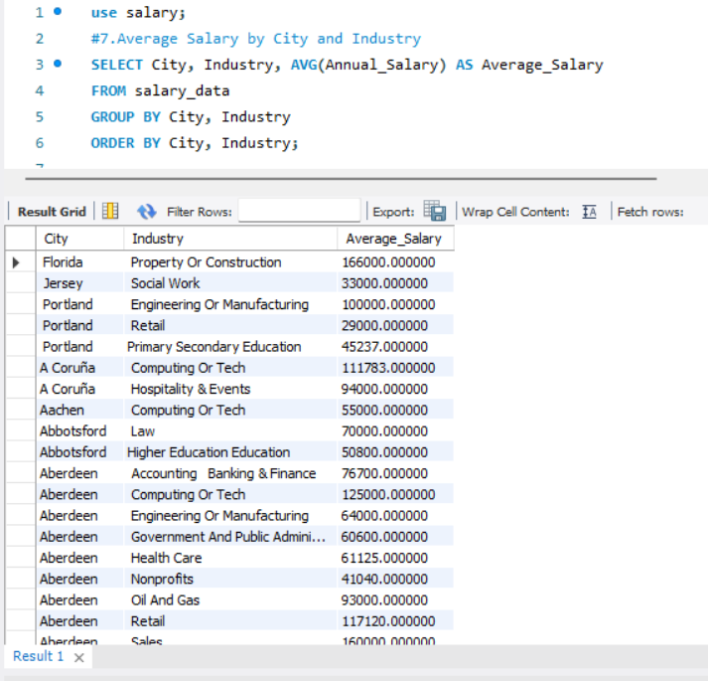
4. Percentage of Employees with Additional Monetary Compensation by Gender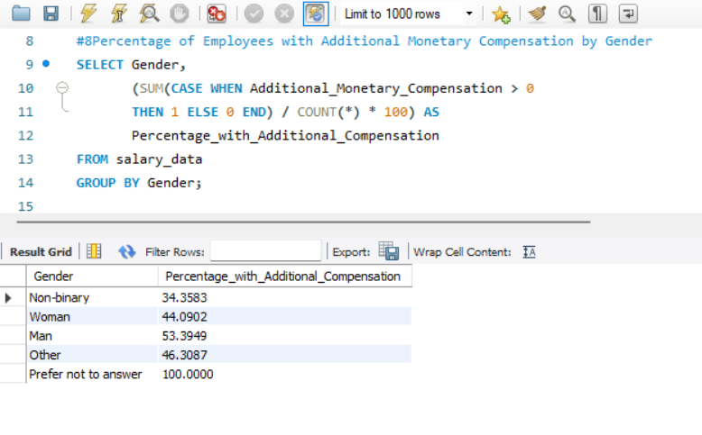
5. Total Compensation by Job Title and Years of Experience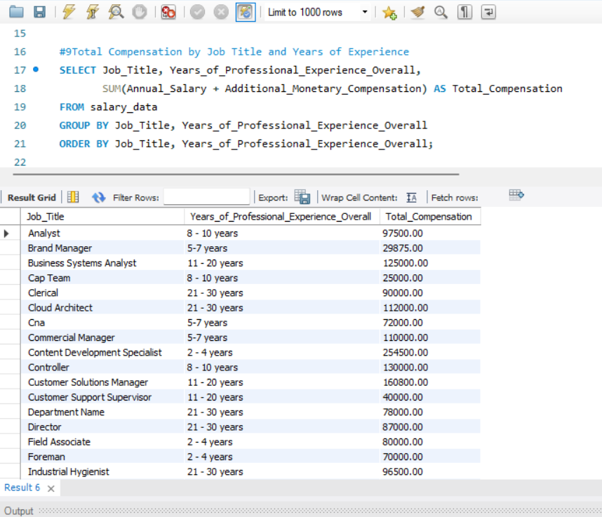
6. Average Salary by Industry, Gender, and Education Level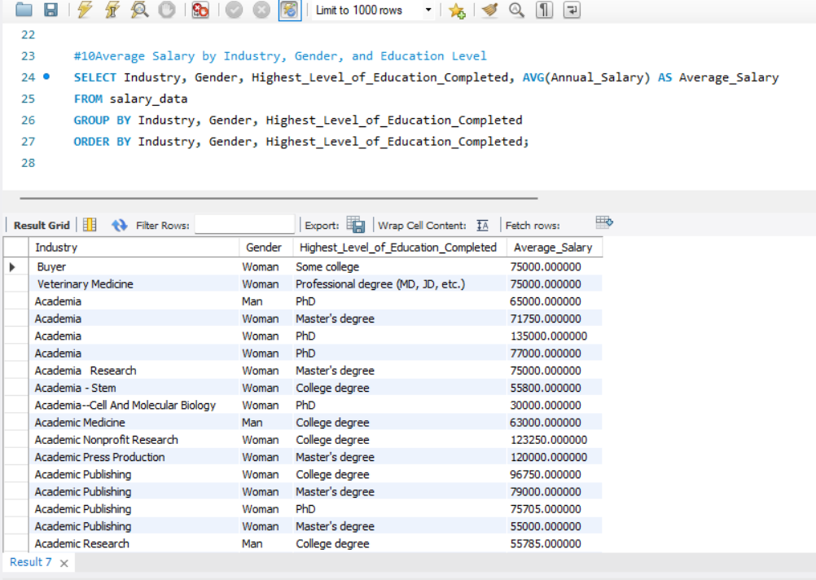

**Step 4: Exporting Data to Excel**

1. **Exported SQL Query Results** from MySQL to CSV files.
2. **Imported Data into Excel**, creating separate sheets for each query result.

**Step 5: Dashboard Creation**

1. **Developed Pivot Tables** to summarize key findings.
2. **Created Visualizations** using bar charts, pie charts, and line graphs to represent salary trends and disparities.
3. **Designed an Interactive Dashboard** with slicers and filters to allow dynamic data exploration.

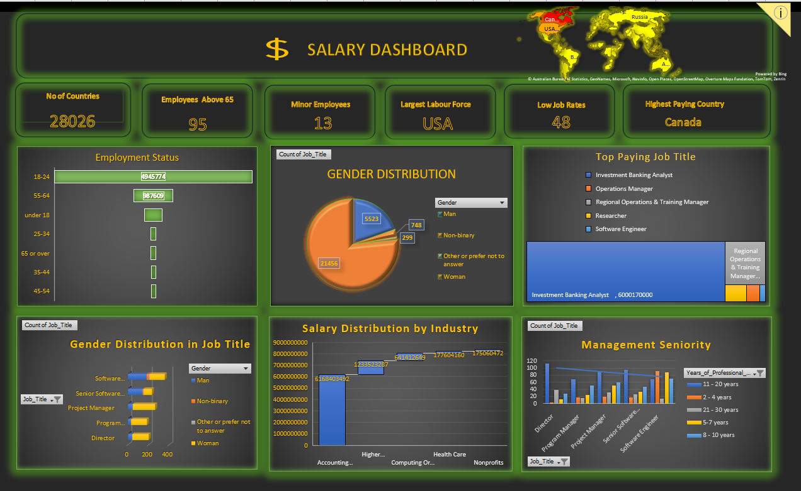

**6. Key Insights:**

1. **Industry-Wise Salary Differences:**
   * The technology sector shows the highest average salaries, while industries like education and retail report lower earnings. 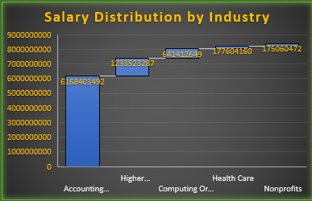
2. **Gender-Based Salary Gaps:**
   * Male professionals tend to earn higher median salaries than female professionals, though the gap narrows at higher experience levels.

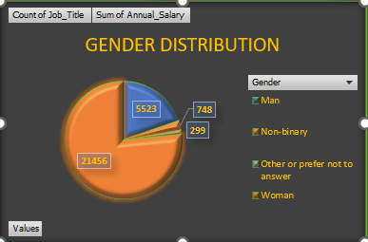

1. **Experience Impact on Salary:**
   * There is a positive correlation between years of experience and salary, with significant jumps observed at the 5-year and 10-year marks.
   * 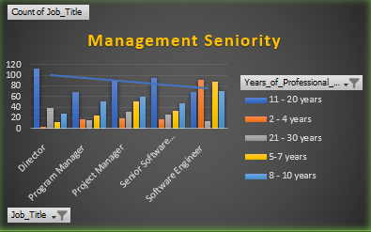
2. **Geographical Variations:**
   * Countries with high living costs tend to offer higher salaries, but adjusted for cost-of-living, some mid-tier countries provide better purchasing power.
   * 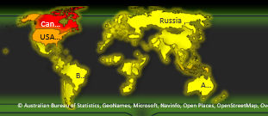
3. **Additional Monetary Compensation:**
   * Employees in tech and finance sectors receive the highest additional compensation, while roles in education and healthcare show lower benefits.
   * 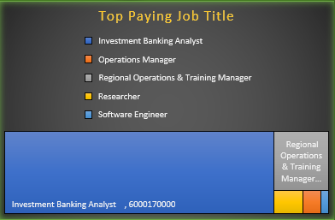

**7. Deliverables:**

1. Cleaned dataset (CSV/Excel file)
2. MySQL database with structured salary data
3. 10 SQL queries and their results exported
4. Excel workbook with individual sheets for each query result
5. Final dashboard with salary insights
6. Written documentation detailing objectives, methodology, findings, and conclusions
7. A presentation file (10 slides) summarizing key insights

**9. Conclusion:**

This analysis provides a comprehensive view of salary trends across industries, highlighting key factors that influence earnings. It underscores the importance of education, experience, and industry choice in determining compensation levels. Additionally, it sheds light on gender disparities and geographical variances, providing valuable insights for professionals and businesses aiming to navigate the job market more effectively. These findings can aid organizations in designing equitable compensation structures and assist individuals in making strategic career decisions.

|  |  |
| --- | --- |
|  |  |
|  |  |
|  |  |
|  |  |
|  |  |
|  |  |
|  |  |
|  |  |

**9. Conclusion:**

This analysis provides a comprehensive view of salary trends across industries, highlighting key factors that influence earnings. It underscores the importance of education, experience, and industry choice in determining compensation levels. Additionally, it sheds light on gender disparities and geographical variances, providing valuable insights for professionals and businesses aiming to navigate the job market more effectively. These findings can aid organizations in designing equitable compensation structures and assist individuals in making strategic career decisions.